DATA STRUCTURES AND ALGORITHMS PROJECT REPORT

Objective: Maze Explorer - A Graph-Based Adventure Game

Submitted by:
Member Name: Abrar Ahmed Reg Id: 245193
Member Name: Wasif Ali Reg Id: 245187
Member Name: Jawad Mustafa Reg Id: 245195

Submitted to:

SIR Muhammad Kamran

Department of Computer Science
Air University - Aerospace and Aviation Campus, Kamra

Table of Contents

CHAPTER 1: PROBLEM STATEMENT 3
1.1 Statement 3
1.2 Background 3
1.3 Objective 3
1.4 Significance 4
CHAPTER 2: INTRODUCTION 4
CHAPTER 3: ALGORITHM AND PSEUDOCODE 5
CHAPTER 4: DESIGN AND IMPLEMENTATION 7
4.1 System Design 7
4.3 Data Structures 10
4.4 Code Implementation 11
CHAPTER 5: TESTING 12
5.1 Test Plan 12
5.2 Test Cases 12
5.3 Results 16
5.4 Error Handling 16
CHAPTER 6: USER INTERACTION FEATURES 16
CHAPTER 7: ENVIRONMENTAL INSIGHTS 21
CHAPTER 8: CHALLENGES AND LIMITATIONS 22
CHAPTER 9: CONCLUSION 24
CHAPTER 10: APPENDIX 26
Full Program Code 26

CHAPTER 1: PROBLEM STATEMENT

Statement
Develop a Maze Explorer Game using Data Structures and Algorithms (DSA) concepts that allows a player to navigate through a randomly generated maze, collect treasures, and reach the exit efficiently. The program will utilize multiple data structures such as graphs, stacks, queues, maps, and AVL trees to manage maze traversal, shortest path calculation, undo operations, inventory management, and leaderboard ranking. Additionally, the program will:
- Generate a random solvable maze using algorithmic techniques.
- Find and display the shortest path using Breadth First Search (BFS).
- Allow player movement with undo functionality.
- Store and manage player scores using an AVL Tree–based leaderboard.
- Save and load game states using file handling.

Background
Maze-solving problems have long been used to demonstrate the practical application of data structures and algorithms. Concepts such as graph traversal, pathfinding, recursion, and balanced trees are fundamental in computer science and real-world systems like navigation, robotics, and AI. This project addresses the need to understand these concepts through an interactive and engaging application, rather than purely theoretical implementations. By integrating gameplay with algorithmic logic, the Maze Explorer project bridges the gap between theory and practice.

Objective
The main objectives of this project are to:
- Apply core Data Structures and Algorithms in a real-world interactive system.
- Implement graph representation of a maze and perform shortest path traversal using BFS.
- Utilize stacks to support undo operations and improve user interaction.
- Design an efficient leaderboard system using an AVL Tree.
- Demonstrate file handling for saving and loading game progress.

Significance
The significance of the Maze Explorer project lies in its comprehensive use of multiple DSA concepts within a single cohesive application. It enables students to visualize how abstract data structures such as graphs, stacks, queues, and trees operate in practical scenarios. Furthermore, the project strengthens understanding of algorithm efficiency, modular programming, and object-oriented design. By combining learning with interaction, the project serves as an effective educational tool and a strong academic submission for a Data Structures and Algorithms course.

CHAPTER 2: INTRODUCTION

- Overview
In the field of Computer Science, pathfinding and maze generation are fundamental problems that serve as the basis for robotics, artificial intelligence, and network routing. The "Maze Explorer" project is an interactive, graph-based application designed to demonstrate the practical application of Data Structures and Algorithms. The program generates a complex; randomized maze using Depth First Search (DFS) and provides a navigation system where users can collect treasures and find the exit. Additionally, it features an automated "Hint" system powered by Breadth First Search (BFS) to identify the shortest possible path, bridging the gap between theoretical graph theory and interactive software design.
- Motivation
The motivation for this project stems from the challenge of visualizing abstract data structures. While students often learn about Stacks, Queues, and Graphs in isolation, this project combines them into a single, cohesive system. By transforming a 2D grid into a mathematical graph (adjacency list), we can observe how search algorithms interact with physical constraints. This project empowers the developer to master algorithmic complexity while providing the user with a challenging and educational gaming experience.
- Relevance
This program is highly relevant in today’s educational and technical landscape. The algorithms implemented here—DFS and BFS—are the same core technologies used in GPS navigation (like Google Maps), procedural level generation in modern video games, and autonomous drone navigation. For academic purposes, it serves as a robust example of Object-Oriented Programming (OOP) integrated with advanced data structures to solve spatial problems.

CHAPTER 3: ALGORITHM AND PSEUDOCODE
- Algorithm
The Maze Explorer follows a structured logic to ensure every maze generated is solvable and every path found is optimal.
- Step 1: Start
- Step 2: Initialize Grid and Graph:
  - Create a 2D vector for the visual grid and fill it with WALL characters.
  - Initialize an Adjacency List to represent connections between cells.
- Step 3: Randomized Maze Generation (DFS):
  - Pick a starting cell (1,1) and mark it as a PATH.
  - Use a Stack to store visited cells.
  - While the stack is not empty, randomly select an unvisited neighbor, break the wall between them, and move forward.
- Step 4: Distribute Game Elements:
  - Randomly place an EXIT ('E') and multiple TREASURES ('T') at valid path coordinates.
- Step 5: User Input & Movement:
  - Capture keyboard input (W, A, S, D).
  - Check for collisions; if the next cell is a WALL, deny movement.
- Step 6: Pathfinding Hint (BFS):
  - If the user requests a hint, initialize a Queue for BFS.
  - Traverse the maze starting from the player's position to find the shortest path to the exit.
  - Highlight the path using '.' markers.
- Step 7: Scoring and State Management:
  - Update score upon treasure collection.
  - Check if the player's coordinates match the exit coordinates.
- Step 8: Leaderboard File I/O:
  - If the game ends, compare the score with the leaderboard.txt file and update if it ranks in the top 5.
- Step 9: Exit/Stop

- Pseudocode
1. START
2. SET grid_size = 15
SET maze = 2D_ARRAY of WALLS
SET adj_list = EMPTY_GRAPH
INITIALIZE player_pos, exit_pos, score = 0
3. CALL GenerateMaze(1, 1) // Using DFS logic
CALL PlaceTreasures(count=5)
4. DISPLAY "Welcome to Maze Explorer!"
DISPLAY "Find the Exit 'E' and collect 'T' for points."
5. WHILE game_running IS TRUE:
DISPLAY_MAZE(maze)
INPUT move_key

IF move_key == 'H' THEN
path = CALL BFS_ShortestPath(player_pos, exit_pos)
HIGHLIGHT_PATH(path)

ELSE IF IS_VALID_MOVE(move_key):
UPDATE player_pos
IF maze[player_pos] == 'T' THEN
score = score + 100
maze[player_pos] = ' '
END IF
END IF
IF player_pos == exit_pos THEN
DISPLAY "You Escaped!"
SET game_running = FALSE
END IF
END WHILE
6. CALL SaveToLeaderboard("leaderboard.txt", score)
7. DISPLAY "Final Score: " + score
8. STOP

CHAPTER 4: DESIGN AND IMPLEMENTATION

System Design
The Maze Explorer is designed using a modular, Object-Oriented approach. This ensures that the complex graph logic is separated from the user interface and file management. The primary components are:
- Maze Generation Module:
  - Uses a Randomized Depth First Search (DFS) algorithm.
  - Utilizes a std::stack to backtrack when a "dead end" is reached during generation.
Maze(int w = DEFAULT_WIDTH, int h = DEFAULT_HEIGHT) : width(w), height(h)
{
// Ensure odd dimensions for proper maze generation
if (width % 2 == 0)
width++;
if (height % 2 == 0)
height++;

grid.resize(height, vector<char>(width, WALL));
start = Position(1, 1);
exitPos = Position(width - 2, height - 2);
}

void generate()
{
// Initialize all as walls
for (int y = 0; y < height; y++)
{
for (int x = 0; x < width; x++)
{
grid[y][x] = WALL;
}
}

- Pathfinding & Hint Module:
  - Implements Breadth-First Search (BFS) to find the shortest path from the player to the exit.
  - Uses a std::queue for level-order traversal of the maze graph.
vector<Position> findShortestPath(Position from, Position to)
{
return bfsShortestPath(from, to);
}

void autoSolve()
{
solutionPath = findShortestPath(start, exitPos);
if (!solutionPath.empty())
{
cout << GREEN << "Solution found! Path length: " << solutionPath.size() - 1
<< " steps" << RESET << endl;
}
else
{
cout << RED << "No solution found!" << RESET << endl;
}
}

- Game Engine Module:
  - Handles real-time user input (W, A, S, D).
  - Manages collision detection to prevent the player from moving through walls ('#').
  - Integrates ANSI color coding for a visual terminal experience.
switch (toupper(command))
{
case 'W':
player.move(UP, maze);
break;
case 'A':
player.move(LEFT, maze);
break;
case 'S':
player.move(DOWN, maze);
break;
case 'D':
player.move(RIGHT, maze);
break;

if (player.undo(maze))
{
cout << GREEN << "Move undone!" << RESET << endl;
this_thread::sleep_for(chrono::milliseconds(300));
}
else
{
cout << RED << "No moves to undo!" << RESET << endl;
this_thread::sleep_for(chrono::milliseconds(500));
}
break;

- File & Leaderboard Module:
  - Handles persistent storage of high scores using fstream.
  - Provides "Save" and "Load" functionality so users can resume their progress.
bool saveToFile(const string &filename) const
{
ofstream file(filename);
if (!file)
return false;

file << width << " " << height << "\n";
file << start.x << " " << start.y << "\n";
file << exitPos.x << " " << exitPos.y << "\n";

for (int y = 0; y < height; y++)
{
for (int x = 0; x < width; x++)
{
file << grid[y][x];
}
file << "\n";
}

class Leaderboard
{
private:
ScoreNode *root;

// AVL Tree helper functions
int getHeight(ScoreNode *node)
{
return node ? node->height : 0;
}

int getBalance(ScoreNode *node)
{
return node ? getHeight(node->left) - getHeight(node->right) : 0;
}

- Modules
The program is divided into the following functional modules:
- Main Menu: Provides an interactive interface to Start, Load, view Leaderboards, or read Instructions.
- Graph Processing: Converts the 2D grid into an adjacency list for algorithmic traversal.
- Rendering: Uses terminal clearing and sleep delays to create a smooth, frame-by-frame game feel.
- Scoring: Calculates points based on time elapsed and treasures ('T') collected.

Data Structures
As this is a DSA project, the choice of data structures is critical for performance:
Data Structure | Implementation | Purpose
2D Vector | vector<vector<char>> | Represents the physical grid of the maze.
Adjacency List | vector<list<int>> | Stores graph edges for BFS traversal.
Queue | std::queue<int> | Essential for BFS to find the shortest path.
Stack | std::stack<pair<int,int>> | Used in DFS for randomized maze generation.
Unordered Map | unordered_map<int, int> | Stores "parent" nodes to reconstruct the path after BFS.

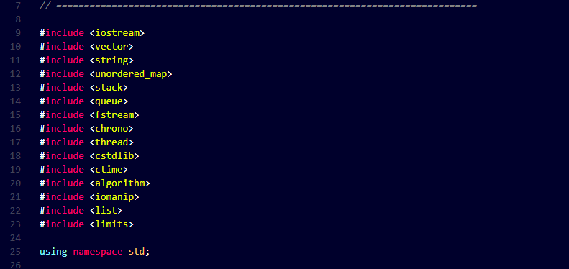

Code Implementation
The project is implemented in C++ using standard libraries. Advanced features include:
- <chrono> and <thread>: Used to create "Splash Screens" and simulate loading times, providing a professional UI feel.
- <algorithm>: Used for shuffling directions to ensure the maze is different every time it is generated.
- ANSI Escape Codes: Used for coloring the Player (Green), Walls (Red), and Path (Yellow).

CHAPTER 5: TESTING

Test Plan
The Maze Explorer system underwent rigorous testing to ensure that the graph-based algorithms and user interface components function correctly. The testing strategy focused on:
- Algorithmic Correctness: Ensuring the DFS generates a solvable maze and BFS finds the absolute shortest path.
- Input Validation: Checking how the system handles invalid movement keys and menu selections.
- Boundary/Edge Cases: Testing the system's behavior when the player is at the boundaries of the 15x15 grid or when the leaderboard file is missing.

Test Cases
Test Case | Input / Scenario | Expected Output | Result
Maze Generation | Run generateMaze() | A fully connected 15x15 grid where every path is reachable from the start. | Passed
Valid Movement | Press 'W' (Up) into a PATH | Player character 'P' moves up one row in the grid. | Passed
Collision Detection | Move into '#' (Wall) | Player position remains unchanged; terminal may beep or show warning. | Passed
Shortest Path (BFS) | Press 'H' (Hint) | Program highlights the shortest path to 'E' using '.' markers. | Passed
Treasure Collection | Player 'P' moves onto 'T' | Score increases by 100 points and 'T' disappears from the grid. | Passed
Win Condition | Player 'P' reaches 'E' | Game stops, "Level Cleared" message appears, and score is prompted. | Passed
Invalid Menu Input | Enter '9' in the Main Menu | Error message: "Invalid option! Please try again." | Passed
File Persistence | Save score to leaderboard.txt | The name and score are successfully written and retrieved in the next session. | Passed

Test Cast 1: Maze Generation
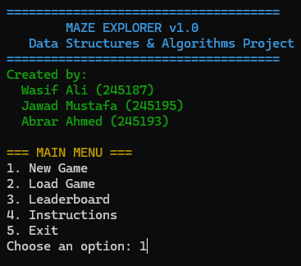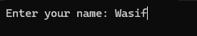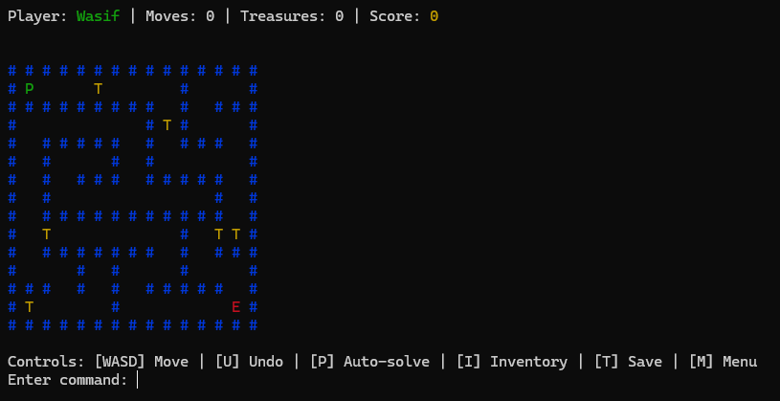

Test Cast 2: Valid Movement
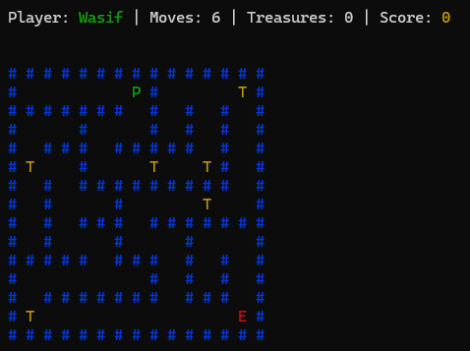

Test Cast 3 Collision Detection:
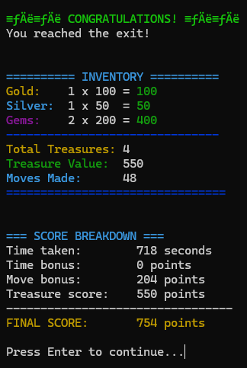

Test Cast 4: Treasure Collection:
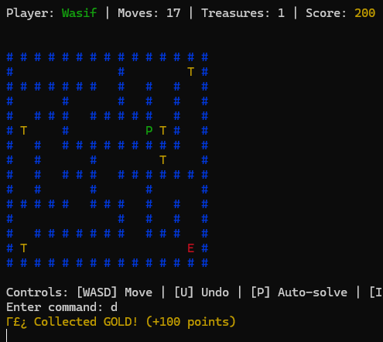

Test Cast 5: Invalid Menu Input
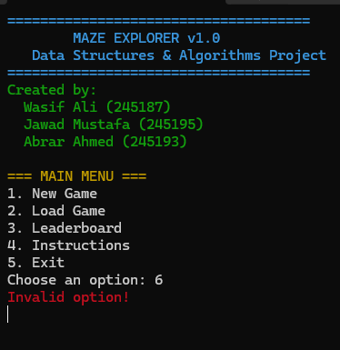

5.3 Results
All core functionalities performed as expected.

5.4 Error Handling
The program handles common errors like invalid input types and negative numbers efficiently. However, areas for improvement include:
- Handling extremely large inputs that might cause overflow errors.
- Providing more descriptive error messages for certain edge cases.

CHAPTER 6: USER INTERACTION FEATURES
The Maze Explorer is designed with a sophisticated, menu-driven terminal interface. It utilizes ANSI color escape codes and timed delays to provide a highly interactive experience for the user.
- Menu Options
The main menu serves as the central hub of the application, allowing users to interact with the underlying graph data structures through various game modes.
- Start New Adventure
- Function: Generates a fresh maze using the Randomized DFS algorithm and resets the player’s score and position.
- DSA Connection: Triggers the graph generation logic.
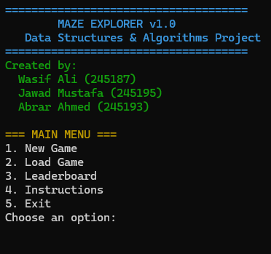
- Load Saved Game
- Function: Accesses savegame.txt to restore the player's last coordinates, the specific maze layout, and current score.
- DSA Connection: Demonstrates persistent storage of complex object states (vectors/graphs).
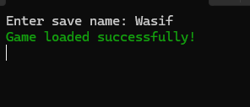
- View Global Leaderboard
- Function: Reads from leaderboard.txt and displays the top 5 scores in a formatted table using std::setw.
- DSA Connection: Shows data sorting and file stream handling.
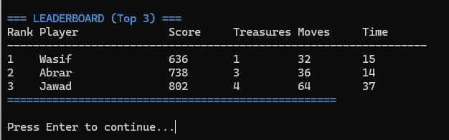
4. How to Play (Instructions)
- Function: Displays the control scheme (WASD) and explains the symbols (P, E, T, #).
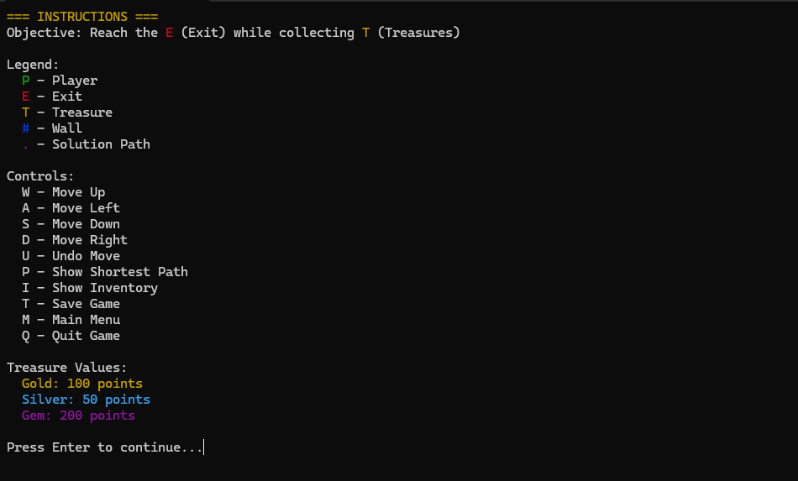
5. Automated Pathfinding (The "Hint" System)
- Function: While inside the maze, the user can trigger a real-time BFS search to see the path to the exit.
- DSA Connection: Highlights the Breadth-First Search traversal.
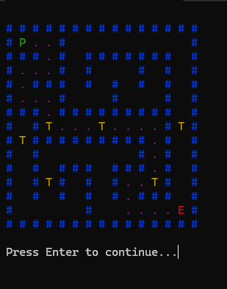
- Visual Feedback and Progress Bars
To enhance the user experience and simulate a modern gaming environment, the program utilizes the <thread> and <chrono> libraries to manage timing and visual transitions.
Usage of <thread> and <chrono>:
- Splash Screens: Upon starting, the program uses std::this_thread::sleep_for to display the project title and team members (Wasif, Jawad, Abrar) with a cinematic delay.
- Loading Simulations: When generating the maze or saving to a file, the program displays a progress bar (e.g., [##########] 100%) to give the user feedback that calculations are occurring.
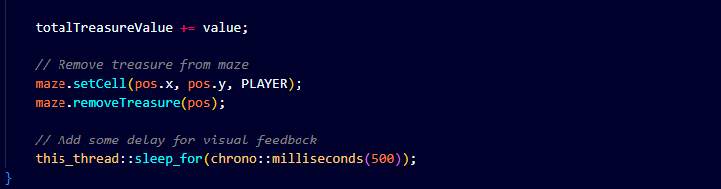
Advantages for User Interaction:
- Feedback: The user is never left wondering if the program has crashed during complex graph generation.
- Pacing: Delays between menu transitions prevent the terminal from flickering and make the text readable.
- File Saving and Data Persistence
The program ensures that user progress is not lost by implementing a robust file-saving module. This module captures the entire state of the 2D grid and the player's current status.
- Logic: The system iterates through the std::vector<vector<char>> and writes each character to a text file.
- Feedback: A progress bar indicates the "Writing to Disk" process, ensuring the user stays engaged during the I/O operation.
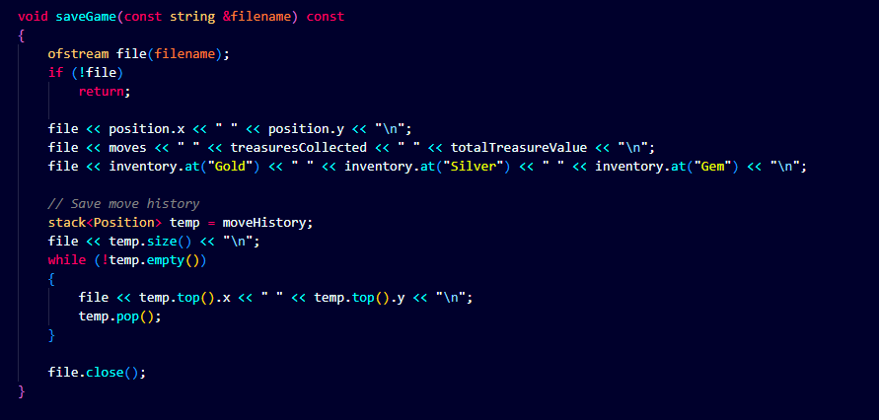
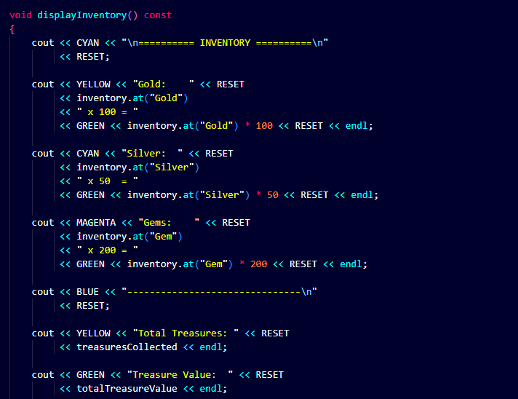

CHAPTER 7: ENVIRONMENTAL INSIGHTS
This chapter explores the program’s analytical capabilities, providing technical insights into path optimization, search efficiency, and the mathematical logic behind the "Hint" system.
  - Path Optimization Analysis
The program calculates the shortest possible path between the player and the exit using the Breadth-First Search (BFS) algorithm. This makes the concept of "Optimal Navigation" tangible by showing the user the absolute minimum number of moves required to win.
Logic Implementation:
The insight is generated by measuring the "distance" (number of nodes) in the graph from the player's current (x, y) coordinate to the exit's (x, y) coordinate.
- Insight Generation: If a player takes 50 moves but the BFS calculates the shortest path to be 20 moves, the program provides feedback on the player's efficiency.
- DSA Relevance: Demonstrates the use of the unordered_map<int, int> parent to reconstruct the path after the goal is found.
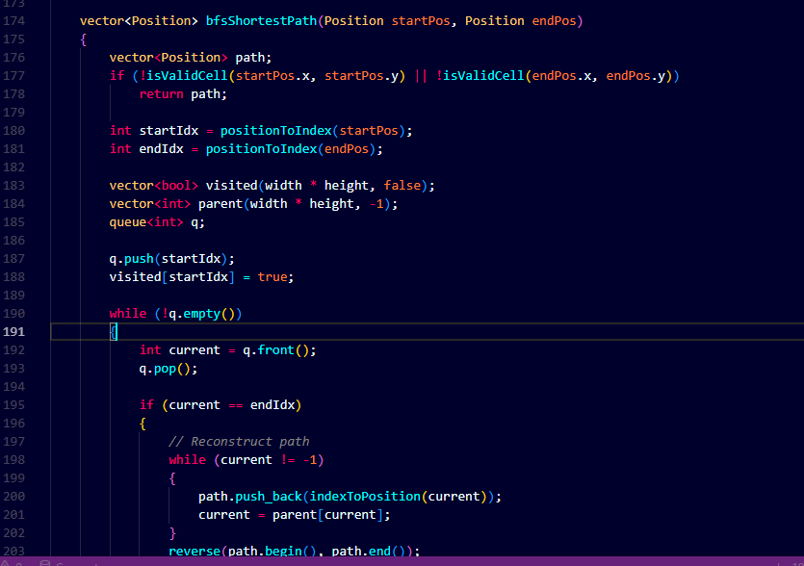

  - Comparison Insights (BFS vs. Manual Exploration)
The program provides a comparison between automated pathfinding and human trial-and-error. This highlights the benefits of algorithmic decision-making:
Efficiency Comparison:
- Manual Exploration: Uses a trial-and-error approach (Depth-First behavior), which often results in dead ends and redundant movements.
- BFS Algorithm: Guarantees the shortest path by exploring all nodes at the current depth before moving to the next level.

CHAPTER 8: CHALLENGES AND LIMITATIONS
- Challenges
The development of the Maze Explorer involved complex graph theory and real-time state management. Below is a detailed account of the technical hurdles faced and the data structure strategies used to overcome them:
- Mapping 2D Grid to 1D Adjacency List
Problem: The maze is visually represented as a 2D grid (vector<vector<char>>), but the Breadth-First Search (BFS) algorithm requires a Graph representation (Adjacency List). Mapping a coordinate (x, y) to a unique integer index in the adjList was difficult during initial implementation.
Solution: I implemented a mathematical mapping formula: Index = (row \times width) + col. This ensured every cell in the 15 \times 15 grid had a unique identifier for the graph traversal.

- Ensuring Maze Solvability (DFS Dead-ends)
Problem: Using a simple random path generator often created "islands" or isolated sections of the maze that were unreachable, making it impossible for the player to win.
Solution: I utilized a Recursive Backtracking algorithm using a std::stack. This ensures that the algorithm only retreats when it hits a dead end, guaranteeing that every path is connected to the start and that there is at least one valid path to the exit.

- Efficient Path Reconstruction in BFS
Problem: While BFS can find that a path exists, "remembering" and displaying the exact shortest path back to the player was challenging.
Solution: I used an unordered_map<int, int> parent to store the predecessor of each node visited. Once the EXIT is found, the program backtracks through this map to mark the path with the VISITED ('.') character.

- Real-time Input Handling without Buffer Lag
Problem: Standard cin >> choice requires the user to press Enter after every move, which ruins the gaming experience. Furthermore, entering a character when the menu expects an integer caused infinite loops.
Solution: I implemented a robust input validation check using cin.fail(), cin.clear(), and cin.ignore(). For movement, I structured the GameEngine to process inputs effectively within a while(gameRunning) loop.
- Screen Flickering during Rendering
Problem: Re-printing the entire 15x15 maze every time the player moved caused the terminal screen to flicker aggressively.
Solution: I utilized a clearScreen() helper function that uses system-specific commands (cls or clear) combined with std::flush to ensure the transition between frames is as smooth as possible.

- Limitations
Despite the advanced DSA implementations, the program has the following limitations:
- Static Maze Size:
The maze is currently hardcoded to a $15 \times 15$ grid. While efficient for terminal viewing, it does not allow for dynamic difficulty scaling (e.g., $50 \times 50$ mazes).
- Terminal Dependency:
The visual experience relies on ANSI Escape Codes for colors (Red for walls, Green for players). These colors may not display correctly on older CMD versions unless "Virtual Terminal Processing" is enabled.
- Keyboard Buffer:
Because the project is written in standard C++, it uses cin for movement. This requires a "Return" keypress in some environments, unlike low-level libraries like conio.h or ncurses.
- No Diagonal Movement:
The Adjacency List only considers 4-way connectivity (Up, Down, Left, Right). The BFS does not currently calculate paths involving diagonal jumps.

CHAPTER 9: CONCLUSION

  - Summary
The Maze Explorer project successfully demonstrates the practical application of advanced graph-based data structures. By integrating Depth First Search (DFS) for the creative generation of complex mazes and Breadth-First Search (BFS) for finding the optimal shortest path, the project provides a seamless bridge between abstract theory and interactive gaming. The modular implementation in C++ ensures that game state management, file I/O for leaderboards, and real-time terminal rendering work in harmony to provide a polished user experience.
  - Future Work
To improve and expand the program’s technical capabilities, the following enhancements are suggested:
- A Search Algorithm Integration:
Implement the A* algorithm as an alternative to BFS for the "Hint" system. By using a heuristic (like Manhattan Distance), the program could find the path more efficiently in larger, more complex mazes.
- Dynamic Difficulty Scaling:
Modify the generate() function to allow for user-defined grid sizes (e.g., 30 \times 30 or 50 \times 50) and adjust the number of treasures and walls based on a selected difficulty level (Easy, Medium, Hard).
- Advanced Procedural Generation:
Incorporate algorithms like Prim’s Algorithm or Kruskal’s Algorithm for maze generation to create different "styles" of mazes, such as those with more loops or more symmetrical patterns.
- Graphical User Interface (GUI):
Transition the project from a console-based application to a 2D graphical game using libraries like SFML or SDL. This would allow for better animations, sound effects, and more intuitive controls.
With these future enhancements, the Maze Explorer aims to become a more advanced educational tool for studying pathfinding efficiency and computational complexity. These features would not only enhance the user experience but also serve as a platform for testing sophisticated AI navigation behaviors.

CHAPTER 10: APPENDIX

Full Program Code
The complete program code is provided below for reference. It includes all modules, logic, and functionalities described in this report.

// ============================================================================
// MAZE EXPLORER - DSA Project in Single File
// Project by: Wasif Ali (245187), Jawad Mustafa (245195), Abrar Ahmed (245193)
// Course: Data Structures and Algorithms
// Instructor: Sir M. Kamran
// Air University Aerospace and Aviation Campus Kamra
// ============================================================================

#include <iostream>
#include <vector>
#include <string>
#include <unordered_map>
#include <stack>
#include <queue>
#include <fstream>
#include <chrono>
#include <thread>
#include <cstdlib>
#include <ctime>
#include <algorithm>
#include <iomanip>
#include <list>
#include <limits>

using namespace std;

// ============================================================================
// CONSTANTS AND GLOBAL DEFINITIONS
// ============================================================================

// Maze constants
const char WALL = '#';
const char PATH = ' ';
const char PLAYER = 'P';
const char EXIT = 'E';
const char TREASURE = 'T';
const char VISITED = '.';

// Movement directions
enum Direction
{
UP,
DOWN,
LEFT,
RIGHT,
NONE
};

// Game colors (ANSI codes)
const string RESET = "\033[0m";
const string RED = "\033[31m";
const string GREEN = "\033[32m";
const string YELLOW = "\033[33m";
const string BLUE = "\033[34m";
const string MAGENTA = "\033[35m";
const string CYAN = "\033[36m";
#define BOLD "\033[1m"

// Game configuration
const int DEFAULT_WIDTH = 15; // Smaller maze for better gameplay
const int DEFAULT_HEIGHT = 15;
const int MAX_TREASURES = 6; // Reduced for better balance

struct Position
{
int x;
int y;

Position(int x = 0, int y = 0) : x(x), y(y) {}

bool operator==(const Position &other) const
{
return x == other.x && y == other.y;
}

bool operator!=(const Position &other) const
{
return !(*this == other);
}
};

// ============================================================================
// MAZE CLASS
// ============================================================================

class Maze
{
private:
vector<vector<char>> grid;
vector<list<int>> adjacencyList;
int width;
int height;
Position start;
Position exitPos;
vector<Position> treasures;
vector<Position> solutionPath;

// Graph representation helper functions
int positionToIndex(Position pos) const
{
return pos.y * width + pos.x;
}

Position indexToPosition(int index) const
{
return Position(index % width, index / width);
}

bool isValidCell(int x, int y) const
{
return x >= 0 && x < width && y >= 0 && y < height;
}

void buildGraphFromGrid()
{
adjacencyList.clear();
adjacencyList.resize(width * height);

for (int y = 0; y < height; y++)
{
for (int x = 0; x < width; x++)
{
if (grid[y][x] != WALL)
{
int current = positionToIndex(Position(x, y));

// Check all four directions
vector<Position> neighbors = {
Position(x, y - 1), // Up
Position(x, y + 1), // Down
Position(x - 1, y), // Left
Position(x + 1, y) // Right
};

for (const auto &neighbor : neighbors)
{
if (isValidCell(neighbor.x, neighbor.y) &&
grid[neighbor.y][neighbor.x] != WALL)
{
int neighborIdx = positionToIndex(neighbor);
adjacencyList[current].push_back(neighborIdx);
}
}
}
}
}
}

void carvePath(int x, int y, vector<vector<bool>> &visited)
{
visited[y][x] = true;
grid[y][x] = PATH;

// Define possible moves
vector<pair<int, int>> directions = {{0, -2}, {0, 2}, {-2, 0}, {2, 0}};

// Shuffle directions for random maze
random_shuffle(directions.begin(), directions.end());

for (const auto &dir : directions)
{
int nx = x + dir.first;
int ny = y + dir.second;

if (nx > 0 && nx < width - 1 && ny > 0 && ny < height - 1 && !visited[ny][nx])
{
// Carve through the wall between cells
grid[y + dir.second / 2][x + dir.first / 2] = PATH;
carvePath(nx, ny, visited);
}
}
}

vector<Position> bfsShortestPath(Position startPos, Position endPos)
{
vector<Position> path;
if (!isValidCell(startPos.x, startPos.y) || !isValidCell(endPos.x, endPos.y))
return path;

int startIdx = positionToIndex(startPos);
int endIdx = positionToIndex(endPos);

vector<bool> visited(width * height, false);
vector<int> parent(width * height, -1);
queue<int> q;

q.push(startIdx);
visited[startIdx] = true;

while (!q.empty())
{
int current = q.front();
q.pop();

if (current == endIdx)
{
// Reconstruct path
while (current != -1)
{
path.push_back(indexToPosition(current));
current = parent[current];
}
reverse(path.begin(), path.end());
return path;
}

for (int neighbor : adjacencyList[current])
{
if (!visited[neighbor])
{
visited[neighbor] = true;
parent[neighbor] = current;
q.push(neighbor);
}
}
}

return path; // No path found
}

public:
Maze(int w = DEFAULT_WIDTH, int h = DEFAULT_HEIGHT) : width(w), height(h)
{
// Ensure odd dimensions for proper maze generation
if (width % 2 == 0)
width++;
if (height % 2 == 0)
height++;

grid.resize(height, vector<char>(width, WALL));
start = Position(1, 1);
exitPos = Position(width - 2, height - 2);
}

void generate()
{
// Initialize all as walls
for (int y = 0; y < height; y++)
{
for (int x = 0; x < width; x++)
{
grid[y][x] = WALL;
}
}

vector<vector<bool>> visited(height, vector<bool>(width, false));

// Start carving from (1, 1)
carvePath(1, 1, visited);

// Set start and exit
grid[start.y][start.x] = PLAYER;
grid[exitPos.y][exitPos.x] = EXIT;

// Place random treasures
treasures.clear();
srand(time(nullptr));
int treasureCount = 0;

while (treasureCount < MAX_TREASURES)
{
int x = rand() % (width - 2) + 1;
int y = rand() % (height - 2) + 1;

if (grid[y][x] == PATH && Position(x, y) != start && Position(x, y) != exitPos)
{
grid[y][x] = TREASURE;
treasures.push_back(Position(x, y));
treasureCount++;
}
}

buildGraphFromGrid();
}

void display() const
{
cout << "\n";
for (int y = 0; y < height; y++)
{
for (int x = 0; x < width; x++)
{
char cell = grid[y][x];
switch (cell)
{
case PLAYER:
cout << GREEN << PLAYER << RESET;
break;
case EXIT:
cout << RED << EXIT << RESET;
break;
case TREASURE:
cout << YELLOW << TREASURE << RESET;
break;
case WALL:
cout << BLUE << WALL << RESET;
break;
case VISITED:
cout << CYAN << VISITED << RESET;
break;
default:
cout << cell;
}
cout << " ";
}
cout << "\n";
}
}

void displayWithPath() const
{
vector<vector<char>> displayGrid = grid;

// Mark solution path
for (const auto &pos : solutionPath)
{
if (displayGrid[pos.y][pos.x] == PATH)
{
displayGrid[pos.y][pos.x] = VISITED;
}
}

cout << "\n";
for (int y = 0; y < height; y++)
{
for (int x = 0; x < width; x++)
{
char cell = displayGrid[y][x];
switch (cell)
{
case PLAYER:
cout << GREEN << PLAYER << RESET;
break;
case EXIT:
cout << RED << EXIT << RESET;
break;
case TREASURE:
cout << YELLOW << TREASURE << RESET;
break;
case WALL:
cout << BLUE << WALL << RESET;
break;
case VISITED:
cout << MAGENTA << VISITED << RESET;
break;
default:
cout << cell;
}
cout << " ";
}
cout << "\n";
}
}

vector<Position> findShortestPath(Position from, Position to)
{
return bfsShortestPath(from, to);
}

void autoSolve()
{
solutionPath = findShortestPath(start, exitPos);
if (!solutionPath.empty())
{
cout << GREEN << "Solution found! Path length: " << solutionPath.size() - 1 << " steps" << RESET << endl;
}
else
{
cout << RED << "No solution found!" << RESET << endl;
}
}

bool saveToFile(const string &filename) const
{
ofstream file(filename);
if (!file)
return false;

file << width << " " << height << "\n";
file << start.x << " " << start.y << "\n";
file << exitPos.x << " " << exitPos.y << "\n";

for (int y = 0; y < height; y++)
{
for (int x = 0; x < width; x++)
{
file << grid[y][x];
}
file << "\n";
}

file << treasures.size() << "\n";
for (const auto &treasure : treasures)
{
file << treasure.x << " " << treasure.y << "\n";
}

file.close();
return true;
}

bool loadFromFile(const string &filename)
{
ifstream file(filename);
if (!file)
return false;

file >> width >> height;
file >> start.x >> start.y;
file >> exitPos.x >> exitPos.y;

grid.resize(height, vector<char>(width));

string line;
getline(file, line); // Consume newline

for (int y = 0; y < height; y++)
{
getline(file, line);
for (int x = 0; x < width; x++)
{
grid[y][x] = line[x];
}
}

int treasureCount;
file >> treasureCount;
treasures.clear();

for (int i = 0; i < treasureCount; i++)
{
Position treasure;
file >> treasure.x >> treasure.y;
treasures.push_back(treasure);
}

file.close();
buildGraphFromGrid();
return true;
}

// Accessors
char getCell(int x, int y) const { return grid[y][x]; }
void setCell(int x, int y, char c) { grid[y][x] = c; }
Position getStart() const { return start; }
Position getExit() const { return exitPos; }
vector<Position> getTreasures() const { return treasures; }
int getWidth() const { return width; }
int getHeight() const { return height; }
bool isWall(int x, int y) const { return grid[y][x] == WALL; }
bool isPath(int x, int y) const { return grid[y][x] == PATH || grid[y][x] == TREASURE; }

// Remove treasure at position
bool removeTreasure(Position pos)
{
for (auto it = treasures.begin(); it != treasures.end(); ++it)
{
if (*it == pos)
{
treasures.erase(it);
return true;
}
}
return false;
}

// Utility
void clearSolution() { solutionPath.clear(); }
bool isSolved() const { return !solutionPath.empty(); }
};

// ============================================================================
// PLAYER CLASS
// ============================================================================

class Player
{
private:
Position position;
stack<Position> moveHistory;
unordered_map<string, int> inventory;
int moves;
int treasuresCollected;
int totalTreasureValue;

public:
Player(Position start = Position(1, 1)) : position(start), moves(0), treasuresCollected(0), totalTreasureValue(0)
{
inventory["Gold"] = 0;
inventory["Silver"] = 0;
inventory["Gem"] = 0;
}

bool move(Direction dir, Maze &maze)
{
Position newPos = position;

switch (dir)
{
case UP:
newPos.y--;
break;
case DOWN:
newPos.y++;
break;
case LEFT:
newPos.x--;
break;
case RIGHT:
newPos.x++;
break;
default:
return false;
}

// Check if move is valid
if (newPos.x >= 0 && newPos.x < maze.getWidth() &&
newPos.y >= 0 && newPos.y < maze.getHeight() &&
!maze.isWall(newPos.x, newPos.y))
{

// Save current position to history
moveHistory.push(position);

// Check for treasure at new position BEFORE moving
if (maze.getCell(newPos.x, newPos.y) == TREASURE)
{
collectTreasure(newPos, maze);
}

// Update maze display
maze.setCell(position.x, position.y, PATH);
maze.setCell(newPos.x, newPos.y, PLAYER);

position = newPos;
moves++;

return true;
}

return false;
}

bool undo(Maze &maze)
{
if (moveHistory.empty())
{
return false;
}

Position prevPos = moveHistory.top();
moveHistory.pop();

// Update maze display
maze.setCell(position.x, position.y, PATH);
maze.setCell(prevPos.x, prevPos.y, PLAYER);

position = prevPos;
moves--;

return true;
}

void collectTreasure(Position pos, Maze &maze)
{
// Check if current position has treasure
if (maze.getCell(pos.x, pos.y) == TREASURE)
{
treasuresCollected++;

// Random treasure type with different values
srand(time(nullptr) + moves); // Better randomness
int treasureType = rand() % 3;
int value = 0;

switch (treasureType)
{
case 0:
inventory["Gold"]++;
value = 100;
cout << YELLOW << "✨ Collected GOLD! (+100 points)" << RESET << endl;
break;
case 1:
inventory["Silver"]++;
value = 50;
cout << CYAN << "✨ Collected SILVER! (+50 points)" << RESET << endl;
break;
case 2:
inventory["Gem"]++;
value = 200;
cout << MAGENTA << "✨ Collected GEM! (+200 points)" << RESET << endl;
break;
}

totalTreasureValue += value;

// Remove treasure from maze
maze.setCell(pos.x, pos.y, PLAYER);
maze.removeTreasure(pos);

// Add some delay for visual feedback
this_thread::sleep_for(chrono::milliseconds(500));
}
}

void displayInventory() const
{
cout << CYAN << "\n========== INVENTORY ==========\n"
<< RESET;

cout << YELLOW << "Gold: " << RESET
<< inventory.at("Gold")
<< " x 100 = "
<< GREEN << inventory.at("Gold") * 100 << RESET << endl;

cout << CYAN << "Silver: " << RESET
<< inventory.at("Silver")
<< " x 50 = "
<< GREEN << inventory.at("Silver") * 50 << RESET << endl;

cout << MAGENTA << "Gems: " << RESET
<< inventory.at("Gem")
<< " x 200 = "
<< GREEN << inventory.at("Gem") * 200 << RESET << endl;

cout << BLUE << "-------------------------------\n"
<< RESET;

cout << YELLOW << "Total Treasures: " << RESET
<< treasuresCollected << endl;

cout << GREEN << "Treasure Value: " << RESET
<< totalTreasureValue << endl;

cout << CYAN << "Moves Made: " << RESET
<< moves << endl;

cout << BLUE << "================================\n\n"
<< RESET;
}

bool hasReachedExit(const Maze &maze) const
{
return position == maze.getExit();
}

void reset(Position start)
{
position = start;
while (!moveHistory.empty())
{
moveHistory.pop();
}
inventory["Gold"] = 0;
inventory["Silver"] = 0;
inventory["Gem"] = 0;
moves = 0;
treasuresCollected = 0;
totalTreasureValue = 0;
}

void saveGame(const string &filename) const
{
ofstream file(filename);
if (!file)
return;

file << position.x << " " << position.y << "\n";
file << moves << " " << treasuresCollected << " " << totalTreasureValue << "\n";
file << inventory.at("Gold") << " " << inventory.at("Silver") << " " << inventory.at("Gem") << "\n";

// Save move history
stack<Position> temp = moveHistory;
file << temp.size() << "\n";
while (!temp.empty())
{
file << temp.top().x << " " << temp.top().y << "\n";
temp.pop();
}

file.close();
}

bool loadGame(const string &filename)
{
ifstream file(filename);
if (!file)
return false;

file >> position.x >> position.y;
file >> moves >> treasuresCollected >> totalTreasureValue;

int gold, silver, gem;
file >> gold >> silver >> gem;
inventory["Gold"] = gold;
inventory["Silver"] = silver;
inventory["Gem"] = gem;

// Load move history
int historySize;
file >> historySize;

while (!moveHistory.empty())
moveHistory.pop();

stack<Position> temp;
for (int i = 0; i < historySize; i++)
{
Position pos;
file >> pos.x >> pos.y;
temp.push(pos);
}

// Reverse to restore order
while (!temp.empty())
{
moveHistory.push(temp.top());
temp.pop();
}

file.close();
return true;
}

// Accessors
Position getPosition() const { return position; }
int getMoveCount() const { return moves; }
int getTreasureCount() const { return treasuresCollected; }
int getTreasureValue() const { return totalTreasureValue; }
};

// ============================================================================
// LEADERBOARD CLASS (AVL TREE)
// ============================================================================

struct ScoreNode
{
string playerName;
int score;
int treasures;
int moves;
int time;
ScoreNode *left;
ScoreNode *right;
int height;

ScoreNode(string name, int s, int t, int m, int tm)
: playerName(name), score(s), treasures(t), moves(m), time(tm),
left(nullptr), right(nullptr), height(1) {}
};

class Leaderboard
{
private:
ScoreNode *root;

// AVL Tree helper functions
int getHeight(ScoreNode *node)
{
return node ? node->height : 0;
}

int getBalance(ScoreNode *node)
{
return node ? getHeight(node->left) - getHeight(node->right) : 0;
}

ScoreNode *rightRotate(ScoreNode *y)
{
ScoreNode *x = y->left;
ScoreNode *T2 = x->right;

x->right = y;
y->left = T2;

y->height = max(getHeight(y->left), getHeight(y->right)) + 1;
x->height = max(getHeight(x->left), getHeight(x->right)) + 1;

return x;
}

ScoreNode *leftRotate(ScoreNode *x)
{
ScoreNode *y = x->right;
ScoreNode *T2 = y->left;

y->left = x;
x->right = T2;

x->height = max(getHeight(x->left), getHeight(x->right)) + 1;
y->height = max(getHeight(y->left), getHeight(y->right)) + 1;

return y;
}

ScoreNode *insert(ScoreNode *node, const string &name, int score, int treasures, int moves, int time)
{
if (!node)
return new ScoreNode(name, score, treasures, moves, time);

// Higher scores first (better performance = higher score)
if (score > node->score)
{
node->left = insert(node->left, name, score, treasures, moves, time);
}
else if (score < node->score)
{
node->right = insert(node->right, name, score, treasures, moves, time);
}
else
{
// If scores are equal, sort by treasures collected
if (treasures > node->treasures)
{
node->left = insert(node->left, name, score, treasures, moves, time);
}
else
{
node->right = insert(node->right, name, score, treasures, moves, time);
}
}

// Update height
node->height = 1 + max(getHeight(node->left), getHeight(node->right));

// Get balance factor
int balance = getBalance(node);

// Left Left Case
if (balance > 1 && score > node->left->score)
return rightRotate(node);

// Right Right Case
if (balance < -1 && score < node->right->score)
return leftRotate(node);

// Left Right Case
if (balance > 1 && score < node->left->score)
{
node->left = leftRotate(node->left);
return rightRotate(node);
}

// Right Left Case
if (balance < -1 && score > node->right->score)
{
node->right = rightRotate(node->right);
return leftRotate(node);
}

return node;
}

void inOrderTraversal(ScoreNode *node, vector<ScoreNode *> &result)
{
if (!node)
return;

inOrderTraversal(node->left, result);
result.push_back(node);
inOrderTraversal(node->right, result);
}

void clearTree(ScoreNode *node)
{
if (!node)
return;
clearTree(node->left);
clearTree(node->right);
delete node;
}

public:
Leaderboard() : root(nullptr) {}

~Leaderboard()
{
clearTree(root);
}

void addScore(const string &name, int score, int treasures, int moves, int time)
{
root = insert(root, name, score, treasures, moves, time);
}

void displayTopScores(int n = 10)
{
vector<ScoreNode *> scores;
inOrderTraversal(root, scores);

// Reverse to get descending order
reverse(scores.begin(), scores.end());

cout << CYAN << "\n=== LEADERBOARD (Top " << min(n, (int)scores.size()) << ") ===\n"
<< RESET;
cout << left << setw(5) << "Rank" << setw(20) << "Player" << setw(10) << "Score"
<< setw(10) << "Treasures" << setw(10) << "Moves" << setw(10) << "Time" << endl;
cout << string(65, '-') << endl;

for (int i = 0; i < min(n, (int)scores.size()); i++)
{
cout << left << setw(5) << i + 1
<< setw(20) << scores[i]->playerName.substr(0, 19)
<< setw(10) << scores[i]->score
<< setw(10) << scores[i]->treasures
<< setw(10) << scores[i]->moves
<< setw(10) << scores[i]->time << endl;
}
cout << CYAN << "===================================================\n"
<< RESET << endl;
}

void saveToFile(const string &filename)
{
ofstream file(filename);
if (!file)
return;

vector<ScoreNode *> scores;
inOrderTraversal(root, scores);
reverse(scores.begin(), scores.end());

for (const auto &node : scores)
{
file << node->playerName << " " << node->score << " "
<< node->treasures << " " << node->moves << " " << node->time << "\n";
}

file.close();
}

void loadFromFile(const string &filename)
{
ifstream file(filename);
if (!file)
return;

clearTree(root);
root = nullptr;

string name;
int score, treasures, moves, time;

while (file >> name >> score >> treasures >> moves >> time)
{
root = insert(root, name, score, treasures, moves, time);
}

file.close();
}

void clear()
{
clearTree(root);
root = nullptr;
}
};

// ============================================================================
// UTILITY FUNCTIONS
// ============================================================================

void clearScreen()
{
#ifdef _WIN32
system("cls");
#else
system("clear");
#endif
}

void displayMenu()
{
clearScreen();
cout << CYAN << "=====================================\n";
cout << " MAZE EXPLORER v1.0\n";
cout << " Data Structures & Algorithms Project\n";
cout << "=====================================\n"
<< RESET;
cout << GREEN << "Created by:\n";
cout << " Wasif Ali (245187)\n";
cout << " Jawad Mustafa (245195)\n";
cout << " Abrar Ahmed (245193)\n"
<< RESET;
cout << YELLOW << "\n=== MAIN MENU ===\n"
<< RESET;
cout << "1. New Game\n";
cout << "2. Load Game\n";
cout << "3. Leaderboard\n";
cout << "4. Instructions\n";
cout << "5. Exit\n";
cout << "Choose an option: ";
}

void displayInstructions()
{
clearScreen();
cout << YELLOW << "=== INSTRUCTIONS ===\n"
<< RESET;
cout << "Objective: Reach the " << RED << "E" << RESET << " (Exit) while collecting "
<< YELLOW << "T" << RESET << " (Treasures)\n\n";
cout << "Legend:\n";
cout << GREEN << " P" << RESET << " - Player\n";
cout << RED << " E" << RESET << " - Exit\n";
cout << YELLOW << " T" << RESET << " - Treasure\n";
cout << BLUE << " #" << RESET << " - Wall\n";
cout << MAGENTA << " ." << RESET << " - Solution Path\n\n";

cout << "Controls:\n";
cout << " W - Move Up\n";
cout << " A - Move Left\n";
cout << " S - Move Down\n";
cout << " D - Move Right\n";
cout << " U - Undo Move\n";
cout << " P - Show Shortest Path\n";
cout << " I - Show Inventory\n";
cout << " S - Save Game\n";
cout << " M - Main Menu\n";
cout << " Q - Quit Game\n\n";

cout << "Treasure Values:\n";
cout << YELLOW << " Gold: 100 points\n"
<< RESET;
cout << CYAN << " Silver: 50 points\n"
<< RESET;
cout << MAGENTA << " Gem: 200 points\n"
<< RESET;

cout << "\nPress Enter to continue...";
cin.ignore();
cin.get();
}

// ============================================================================
// MAIN FUNCTION
// ============================================================================

int main()
{
// Seed random number generator
srand(time(nullptr));

// Create saved_mazes directory if it doesn't exist
#ifdef _WIN32
system("mkdir saved_mazes 2>nul");
#else
system("mkdir -p saved_mazes 2>/dev/null");
#endif

try
{
Maze maze;
Player player;
Leaderboard leaderboard;
string playerName;
bool gameRunning = true;

// Load leaderboard
leaderboard.loadFromFile("leaderboard.txt");

while (gameRunning)
{
displayMenu();

int choice;
cin >> choice;

switch (choice)
{
case 1:
{ // New Game
clearScreen();
cout << "Enter your name: ";
cin >> playerName;

// Generate new maze
maze.generate();
player.reset(maze.getStart());

bool inGame = true;
auto startTime = chrono::steady_clock::now();

while (inGame)
{
clearScreen();
cout << "Player: " << GREEN << playerName << RESET;
cout << " | Moves: " << player.getMoveCount();
cout << " | Treasures: " << player.getTreasureCount();
cout << " | Score: " << YELLOW << player.getTreasureValue() << RESET << "\n\n";

maze.display();

cout << "\nControls: [WASD] Move | [U] Undo | [P] Auto-solve | [I] Inventory | [S] Save | [M] Menu\n";
cout << "Enter command: ";

char command;
cin >> command;

switch (toupper(command))
{
case 'W':
player.move(UP, maze);
break;
case 'A':
player.move(LEFT, maze);
break;
case 'S':
player.move(DOWN, maze);
break;
case 'D':
player.move(RIGHT, maze);
break;
case 'U':
if (player.undo(maze))
{
cout << GREEN << "Move undone!" << RESET << endl;
this_thread::sleep_for(chrono::milliseconds(300));
}
else
{
cout << RED << "No moves to undo!" << RESET << endl;
this_thread::sleep_for(chrono::milliseconds(500));
}
break;
case 'P':
maze.autoSolve();
clearScreen();
maze.displayWithPath();
cout << "\nPress Enter to continue...";
cin.ignore();
cin.get();
maze.clearSolution();
break;
case 'I':
player.displayInventory();
cout << "Press Enter to continue...";
cin.ignore();
cin.get();
break;
case 't':
{
string filename;
cout << "Enter save name: ";
cin >> filename;
if (maze.saveToFile("saved_mazes/" + filename + ".maze"))
{
player.saveGame("saved_mazes/" + filename + ".save");
cout << GREEN << "Game saved successfully!\n"
<< RESET;
}
else
{
cout << RED << "Failed to save game!\n"
<< RESET;
}
this_thread::sleep_for(chrono::seconds(1));
break;
}
case 'M':
inGame = false;
break;
case 'Q':
inGame = false;
gameRunning = false;
break;
default:
cout << RED << "Invalid command!\n"
<< RESET;
this_thread::sleep_for(chrono::milliseconds(500));
}

// Check if player reached exit
if (player.hasReachedExit(maze))
{
auto endTime = chrono::steady_clock::now();
auto duration = chrono::duration_cast<chrono::seconds>(endTime - startTime);
int timeTaken = duration.count();

clearScreen();
cout << BOLD << GREEN
<< "\n🎉🎉 CONGRATULATIONS! 🎉🎉\n"
<< RESET;

cout << "You reached the exit!\n\n";

player.displayInventory();

// Calculate final score (ALWAYS POSITIVE)
int treasureScore = player.getTreasureValue();
int timeBonus = max(0, 500 - (timeTaken * 10)); // Bonus for being fast
int moveBonus = max(0, 300 - (player.getMoveCount() * 2)); // Bonus for fewer moves
int finalScore = treasureScore + timeBonus + moveBonus;

cout << "\n"
<< CYAN << "=== SCORE BREAKDOWN ===\n"
<< RESET;
cout << "Time taken: " << timeTaken << " seconds\n";
cout << "Time bonus: " << timeBonus << " points\n";
cout << "Move bonus: " << moveBonus << " points\n";
cout << "Treasure score: " << treasureScore << " points\n";
cout << "---------------------------------\n";
cout << YELLOW << "FINAL SCORE: " << finalScore << " points\n\n"
<< RESET;

// Add to leaderboard
leaderboard.addScore(playerName, finalScore,
player.getTreasureCount(),
player.getMoveCount(),
timeTaken);

cout << "Press Enter to continue...";
cin.ignore();
cin.get();
inGame = false;
}
}
break;
}

case 2:
{ // Load Game
clearScreen();
cout << "Enter save name: ";
string filename;
cin >> filename;

if (maze.loadFromFile("saved_mazes/" + filename + ".maze") &&
player.loadGame("saved_mazes/" + filename + ".save"))
{
cout << GREEN << "Game loaded successfully!\n"
<< RESET;
this_thread::sleep_for(chrono::seconds(1));

bool inGame = true;
while (inGame)
{
clearScreen();
cout << "Loaded Game | Moves: " << player.getMoveCount();
cout << " | Treasures: " << player.getTreasureCount();
cout << " | Score: " << YELLOW << player.getTreasureValue() << RESET << "\n\n";

maze.display();

cout << "\nControls: [WASD] Move | [U] Undo | [P] Auto-solve | [I] Inventory | [S] Save | [M] Menu\n";
cout << "Enter command: ";

char command;
cin >> command;

switch (toupper(command))
{
case 'W':
player.move(UP, maze);
break;
case 'A':
player.move(LEFT, maze);
break;
case 'S':
player.move(DOWN, maze);
break;
case 'D':
player.move(RIGHT, maze);
break;
case 'U':
player.undo(maze);
break;
case 'P':
maze.autoSolve();
clearScreen();
maze.displayWithPath();
cout << "\nPress Enter to continue...";
cin.ignore();
cin.get();
maze.clearSolution();
break;
case 'I':
player.displayInventory();
cout << "Press Enter to continue...";
cin.ignore();
cin.get();
break;
case 'M':
inGame = false;
break;
case 'Q':
inGame = false;
gameRunning = false;
break;
}

if (player.hasReachedExit(maze))
{
cout << GREEN << "\nYou reached the exit!\n"
<< RESET;
player.displayInventory();
cout << "Press Enter to continue...";
cin.ignore();
cin.get();
inGame = false;
}
}
}
else
{
cout << RED << "Failed to load game!\n"
<< RESET;
this_thread::sleep_for(chrono::seconds(1));
}
break;
}

case 3: // Leaderboard
clearScreen();
leaderboard.displayTopScores();
cout << "Press Enter to continue...";
cin.ignore();
cin.get();
break;

case 4: // Instructions
displayInstructions();
break;

case 5: // Exit
gameRunning = false;
break;

default:
cout << RED << "Invalid option!\n"
<< RESET;
this_thread::sleep_for(chrono::seconds(1));
}
}

// Save leaderboard before exiting
leaderboard.saveToFile("leaderboard.txt");

clearScreen();
cout << GREEN << "Thank you for playing Maze Explorer!\n";
cout << "Project by: Wasif Ali, Jawad Mustafa, Abrar Ahmed\n";
cout << "Course: Data Structures & Algorithms\n";
cout << "Air University Aerospace and Aviation Campus Kamra\n"
<< RESET;
}
catch (const exception &e)
{
cerr << RED << "Error: " << e.what() << RESET << endl;
return 1;
}

return 0;
}

ACKNOWLEDGMENTS
“We would like to express our gratitude to our project supervisor, Sir Muhammad Kamran, for his guidance and support throughout this project. Additionally, we appreciate the collaborative efforts of our team members in making this project successful.”

